Outcome 3: Pro - Forma

Examiner Details
Name: Connor Campbell  Position: Forensic Examiner  Telephone:085862312412  E-mail: 20197790@westlothian.ac.uk | Investigation No: 1  Date/Time: 28/04/2026  Location: WLC Cyber Lab 1  Witness: Christine
Initial Questions
Are systems logged in / turned on?
Are there any other external Devices connected?
Who had access?
Has anything been altered?
What has occurred?
What messages were sent (Not by Email)?
Did any other incident occur?

Scene Description
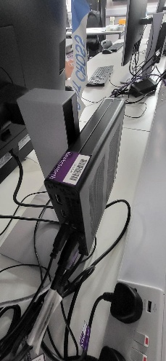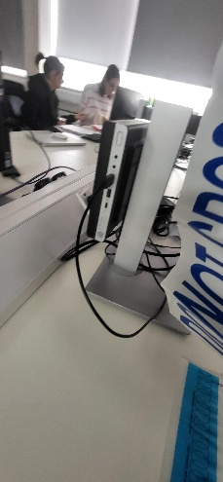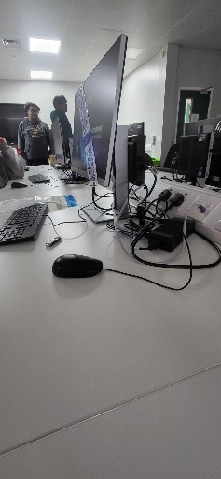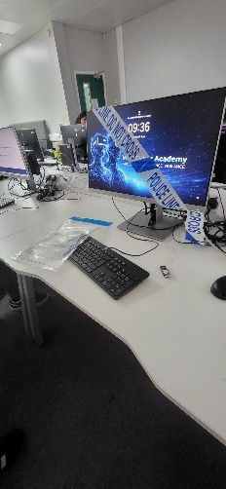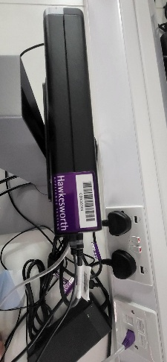

Computer (HP EliteDesk) with Silver and Black USB, multiple ports connected to keyboard (HP), Mouse (HP), Monitor (HP) and ethernet connection.

PC Inventory | Sources of Evidence
Keyboard (HP)  Mouse (HP)  Ethernet  Monitor (HP)  Power Cable  Computer (HP EliteDesk) | Potential digital evidence sources (primary):  - USB devices  - Hard drive  Organisational evidence sources  - Network trace files – pcap files  Esbestikk_Original1  Esbestikk_Original2

Chain of Custody Process
Description of Evidence
Item # | Quantity | Description of Item (Model, Serial #, Condition, Marks, Scratches)
1 | 1 | USB (Silver and Black)
2 | 1 | Esbestikk_Original1
3 | 1 | Esbestikk_Original2
4 | 1 | Esbestikk_Copy1
5 | 1 | Esbestikk_Copy2
6 | 1

Chain of Custody
Item # | Date/Time | Released by  (Signature & ID#) | Received by  (Signature & ID#) | Comments/Location
1 | 28/04/2026 | Esbestikk Manager | Connor #1 | Seized from desk
1 | 28/04/2026 | Connor #1 | Luke #2 | Stored in lockup
1 | 29/04/2026 | Luke #2 | Connor #1 | Collected from Lockup
2, 3 | 29/04/2026 | Connor #1 | Luke #2 | Connor make Copies (item #4 & item #5) & apply write blockers to item and return to item #1 to lockup
3 | 29/04/2026 | Connor #1 | Luke #2 | Connor make Copies (item #4 & item #5) & apply write blockers to item and return to item #1 to lockup
2 | 29/04/2026 | Connor #1 | Luke #2 | Hash verified before sealing and return to lockup
3 | 29/04/2026 | Connor #1 | Luke #2 | Hash verified before sealing and return to lockup

Forensic Tools
Acquisition / Imaging:
- FEX Imager – I used FEX Imager to create a forensic image of the USB, this was done so that all analysis would be done on a copy rather than the original USB to keep integrity and avoid modifications the evidence.
Integrity / Hashing:
- FEX Imager – FEX imager was used to gather the hash values of the evidence both MD5 & SHA-256 to make sure both copies are exact matches to the original device. This ensures that no evidence was altered during acquisition and analysis
Analysis:
- Autopsy – Autopsy was used to analysis and examine the Forensic images and and to help recover digital artefacts from storage devices. This was used to help analyse files, deleted files, metadata and find evidence related to the investigation
Network Support (only if authorised/required):
- Wireshark – Wireshark was used to inspect network traffic inside the PCAP files, this allowed us to identify FTP, Authentication credentials, IP addresses and network activity

Steganography Testing (targeted use):
- JP hide and Seek – was used for Steganography testing and finding hidden files.

Forensic Acquisition and Analysis
Forensic Acquisition
How you acquired it and what you did to it

- First, I used FEX Imager to create a forensic image of the USB to allow me to have a workable copy of the contents of the device that is reproducible and controlled. These copies are what will be used for the analysis rather than the USB. Next, I uploaded it to autopsy to look through files to find anything that could be of use for the investigation. Here we found an email sent that identifies both parties were in contact with each other. Use the PCAP files we used Wireshark allow me to look at network traffic of what protocols were used, what was contained in the packets and timestamps. From this we could see that both parties logged into the system, transferred files and had communication between each other using a txt file. Using JP Hide and seek I was able to find a hidden file that contained information of the company’s processor blueprint.

Analysis
- FEX Image was used to create as forensic image including taking HASH values
- Forensic image was used in autopsy
- The file system was reviewed, and files of note were looked at and noted
- PCAP Files were opened with Wireshark
- Timestamps, Ips, Connections and any & all traffic that was suspicious or “alarming” traffic was noted down.
- JP Hide and seek used to find hidden files
- All findings from both were recorded so that the process could be repeated and verified

Output and Findings
Show all findings and outputs
- Hash values
Acquisition MD5 Hash : Not available
Verification MD5 Hash : e219bf330138be0779ed9f02b3c5dd03
Acquisition SHA1 Hash : Not available
Verification SHA1 Hash : 6933ccfeb448a3fdc1d60bf2aa55f189d81de6fe
Verification SHA256 Hash : ce018e20d886ccc9992c1d0b593026caff586f480650a1b642f414d1fec60582

- File names
- Screenshots
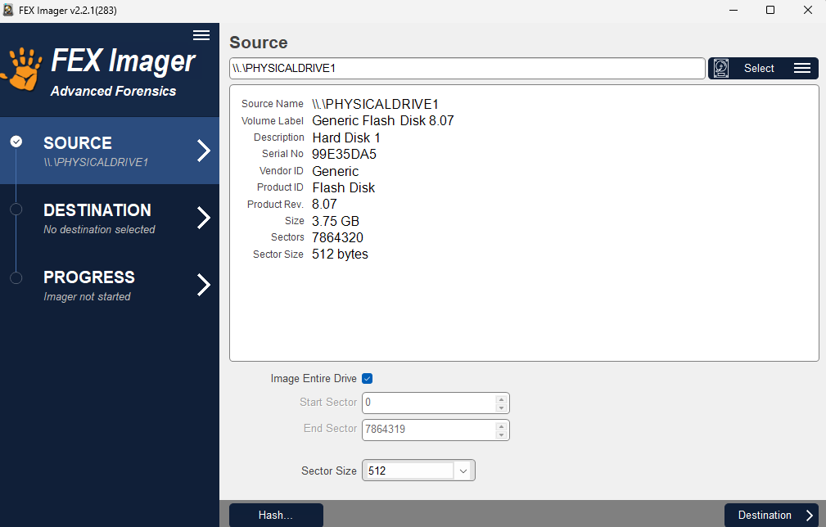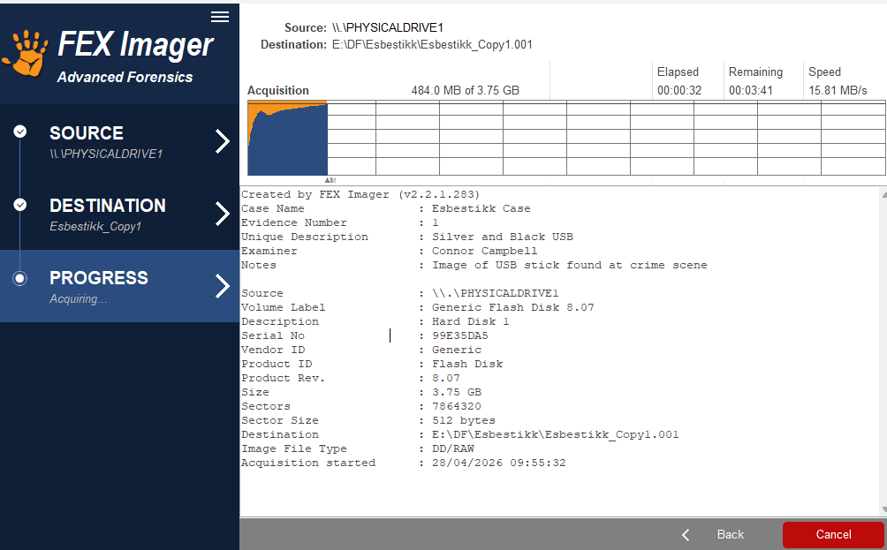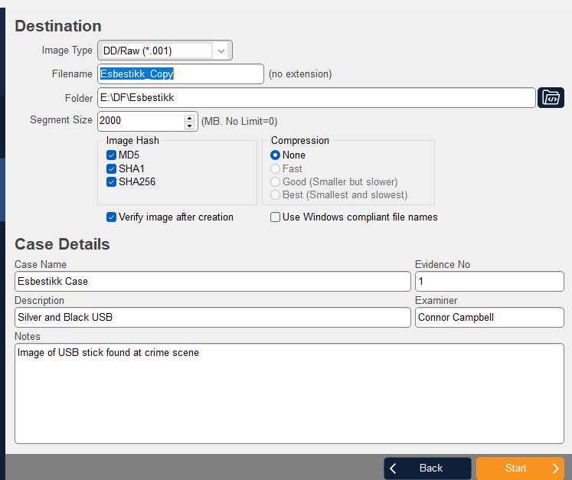

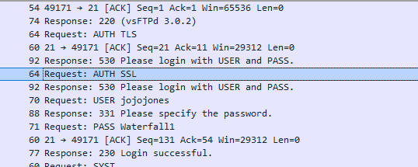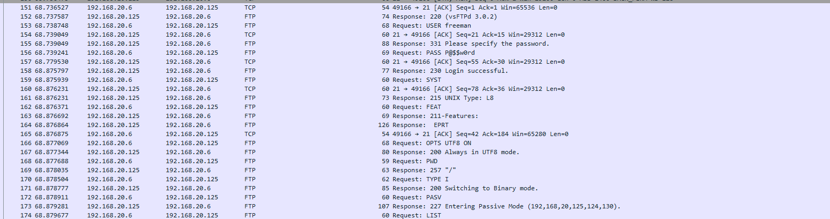

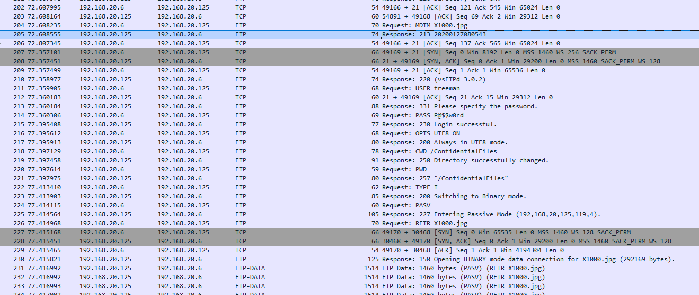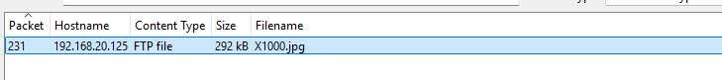
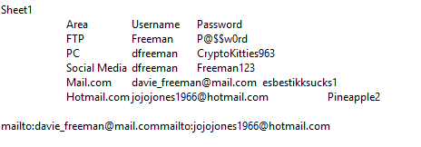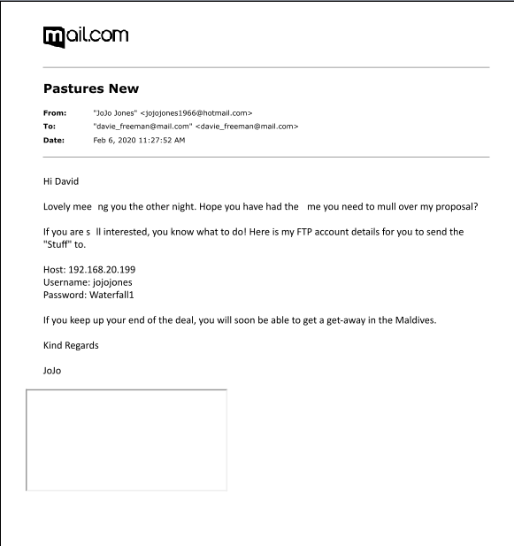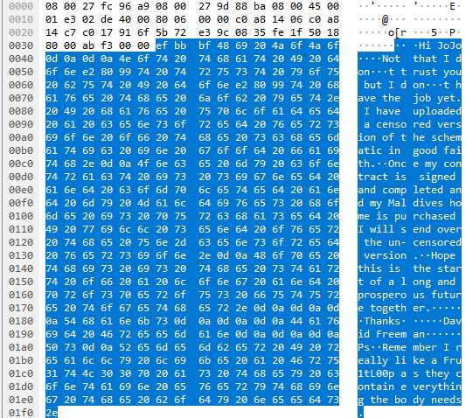
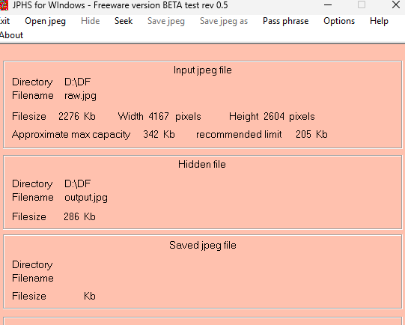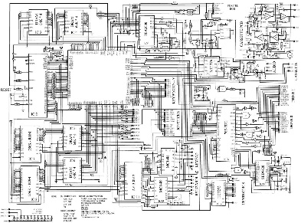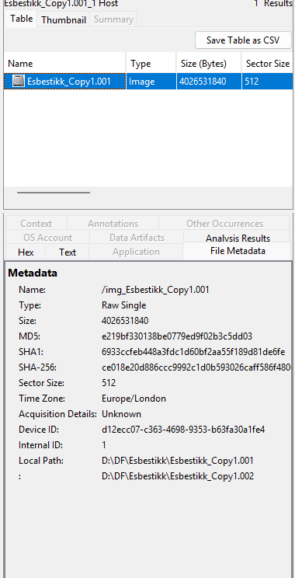

Recommendations
- Add network encryption to prevent confidential information being at risk
- Stronger access controls like role-based access and limiting access to only authorised users
- Using Data loss prevention solutions to restrict transfers of sensitive data.
- Better network monitoring and logging that will alert any suspicious transfers / large file transfers
- Security awareness training for employees is a must to help staff with security risks and company policies
- Regular security audits to identify vulnerabilities

Timeline of Events
Put everything in chronological order – metadata and timestamps will help
Network communication between 192.168.20.6 & 192.168.20.125
User login: USER Freeman PASS: P@$$w0rd
User navigates to /ConfidentialFiles
User retrieves file “RETR X1000.jpg”

Network communication between 192.168.20.6 & 192.168.20.199
User login: USER jojojones PASS: Waterfall1
User navigates to /Storage
User Stores following files: STOR Hi Jojo.txt, BetterBeWorthIt.jpg, X1000-2.jpg

Contemporaneous Notes
- Examined the HP EliteDesk workstation and noticed a USB device connected to the system. Thought the USB could contain important evidence related to the investigation.
- Created a forensic image using FEX Imager and verified the hash values to ensure the evidence remained unchanged. Felt confident the evidence was preserved correctly.
- Analysed the forensic image in Autopsy and reviewed suspicious files and communication. Began to suspect confidential information may have been transferred.
- Opened the PCAP files in Wireshark and identified FTP traffic, usernames and file transfers between systems. Found the communication between David Freeman and “jojojones” suspicious.
- Recorded all findings, timestamps and IP addresses carefully to maintain accurate evidence documentation throughout the investigation.

